**Sourcing Decisions in Supply Chain**

Sourcing is the set of business processes required to purchase goods and services

**Sourcing processes include:**

– Supplier scoring and assessment

– Supplier selection and contract negotiation

– Design collaboration

– Procurement

– Sourcing planning and analysis

**Supplier Selection:**

**Example-1**

– LawnMan, a manufacturer of lawn mowers has historically purchased bearings from a local supplier who charges $1.00per bearing. The purchasing manager has identified another potential source willing to supply the bearings at $0.97 per bearing. The local supplier has an average lead time of 2 weeks and has agreed to deliver the bearing in batches of 2,000. Based on past on-time performance, the purchasing manager estimates that the lead time has a standard deviation of 1 week. The new source has an average lead time of 6 weeks with a standard deviation of 4 weeks. The new source requires a minimum batch size of 8,000 bearings. LawnMan has a holding cost of 25 percent. It currently uses a continuous review policy for managing inventory and aims for a cycle service level of 95 percent. Weekly demand has a mean of 1,000 and a standard deviation of 300 bearings. Which supplier should the purchasing manager go with (ignore ordering cost and focus on material cost and holding cost when making your decision)?

**Problem No. 4. - HW-7** A utility company has weekly demand for a certain type of transformer that is normally distributed with a mean of 100 and a standard deviation of 50. Holding costs are 25% and inventory must be held corresponding to a cycle service level of 95%. The utility company is trying to choose between two suppliers, Reliable Components and Value Electric, who offer the following terms. Reliable sells the transformer for $5,000 with a minimum order of 100, and a lead time of 1 week with a standard deviation of 0.1 week. Value sells the transformer for $4,800 in batches of 1000 with a lead time of 5 weeks and standard deviation of 4 weeks. In both cases, the lead times are normally distributed. What are the annual costs of using each of the suppliers and which supplier should be chosen?

**Make to Order (no contract)**

**Example 2**

The retailer pricing and costing information is as follows: During the summer season, a swimsuit is sold to customers at $125 per unit. The wholesale price paid by the retailer to the manufacturer is $80 per unit. Any swimsuit not sold during the summer season is sold to a discount store for $20. For the manufacturer, we have the following information: Fixed production cost is $100,000. The variable production cost per unit equals $35.

**How much should the retailer order from the manufacturer consider only the 6 demand values)?**

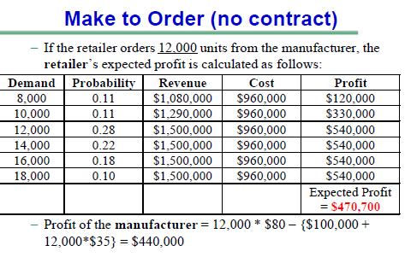

**Problem No. 1**. **Make-to-Stock (no contract) – HW-7** Consider a supply chain for fashion products (such as ski jackets). In this case, the selling season starts in September and is over by December. The sequence of events in this supply chain is as follows. Production starts 12 months before the selling season, before distributors place any orders with the manufacturer. The distributor places orders with the manufacturer six months after beginning of production. At that time, the manufacturer has completed producing the products while the distributor has received firm orders from retailers. Thus, the manufacturer produces ski jackets prior to receiving distributor orders. Demand for ski jackets follows the following pattern:

The distributor’s pricing and cost information is as follows:

• The distributor sells ski jackets to retailers for $125 per unit.

• The distributor pays the manufacturer $80 per unit.

For the manufacturer, we have the following information:

• Fixed cost of production is $100,000.

• The variable production cost per unit equals $55.

• Any ski jacket not purchased by the distributors is sold to a discount store for $20.

**How much should the manufacturer produce (consider only the 6 demand values)?**

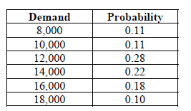

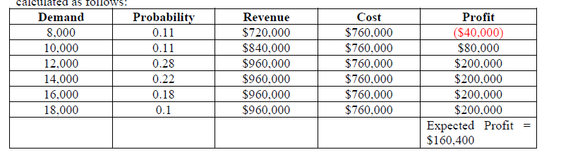

**Make to Order (buy-back contract)**

**Example 3** Refer to Example 2. Suppose that the manufacturer offers tobuy unsold swimsuits from the retailer for $50. How much should the retailer order from the manufacturer (consider only the 6 demand values)?

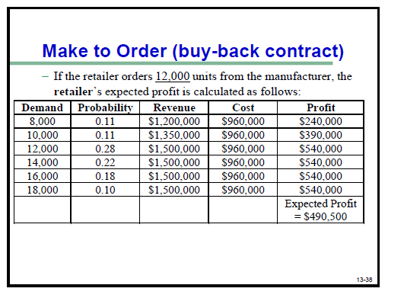

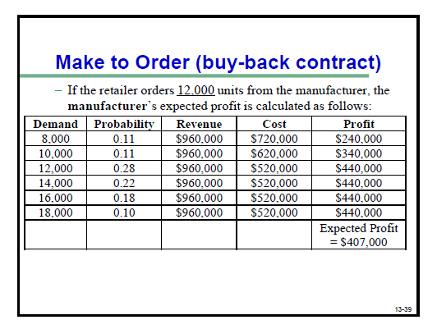

**Problem No. 2**. **Make-to-Stock (pay-back contract) – HW 7** Refer to Problem 1. Suppose that the distributor offers to pay $18 for each unit produced by the manufacturer but not purchased by the distributor. How much should the manufacturer produce (consider only the 6 demand values)?

